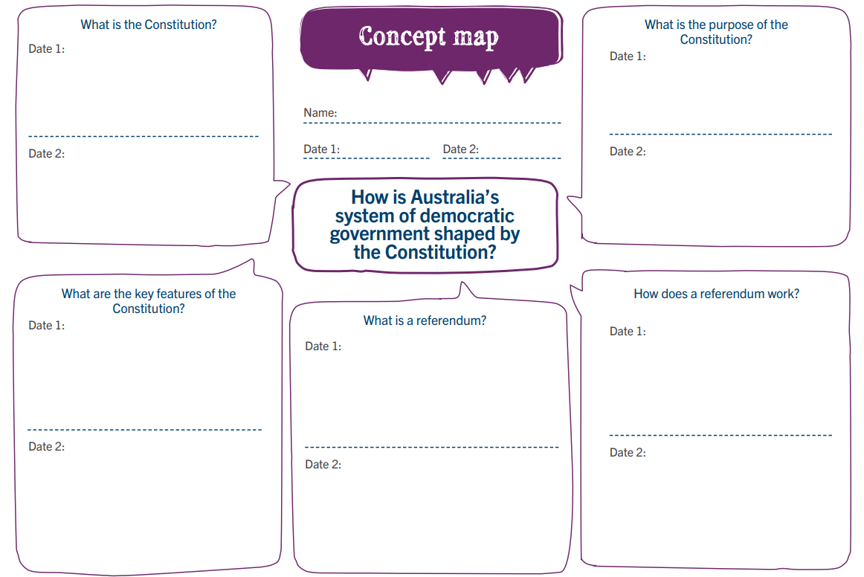

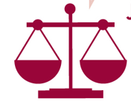
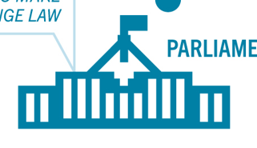

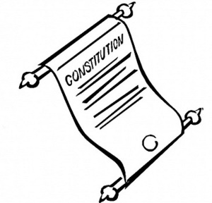

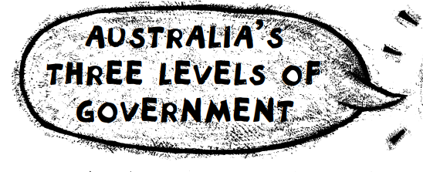
In Australia there are THREE levels of government:
1. _______________________________________
2. _______________________________________
3. _______________________________________
Each level of government:
- ________________________________________________
- ________________________________________________
- ________________________________________________
- ________________________________________________
Each level of government has particular responsibilities.

LOCAL GOVERNMENT is responsible for providing services within their local area. These include: | STATE GOVERNMENT is responsible for: | FEDERAL GOVERNMENT is responsible for:

